Currency Conversion

Definition
# Source: AI Source: Provided by: [Data Path: Persons Table -> ID Column: 1, Name_En Column: Motasem Essam] -> From: [Chatgpt (GPT‑5 Mini)] on [12/10/2025]
Currency Conversion is a data transformation technique in which monetary values in one currency are converted into another currency using an appropriate exchange rate. This ensures that financial data from different countries or periods can be compared or aggregated consistently.

Key Idea
# Source: AI Source: Provided by: [Data Path: Persons Table -> ID Column: 1, Name_En Column: Motasem Essam] -> From: [Chatgpt (GPT‑5 Mini)] on [12/10/2025]
Financial datasets often contain values in multiple currencies, which cannot be analyzed directly. By converting all amounts to a common currency, analysts and models can process the data accurately.

How It Works
# Source: AI Source: Provided by: [Data Path: Persons Table -> ID Column: 1, Name_En Column: Motasem Essam] -> From: [Chatgpt (GPT‑5 Mini)] on [12/10/2025]
- Identify the currency of each transaction.
- Determine the appropriate exchange rate for the date of the transaction.
- Multiply the original value by the exchange rate to get the converted value.

Formula
# Source: AI Source: Provided by: [Data Path: Persons Table -> ID Column: 1, Name_En Column: Motasem Essam] -> From: [Chatgpt (GPT‑5 Mini)] on [12/10/2025]
Amount_{converted}​ = Amount_{original ​}× Exchange Rate

Where:
- ${\text{Amount}}_{\text{original}}$= value in the original currency
- $\text{Exchange Rate}$= conversion rate from the original to target currency
- ${\text{Amount}}_{\text{converted}}$= value in the target currency

Example
# Source: AI Source: Provided by: [Data Path: Persons Table -> ID Column: 1, Name_En Column: Motasem Essam] -> From: [Chatgpt (GPT‑5 Mini)] on [12/10/2025]
Original dataset:
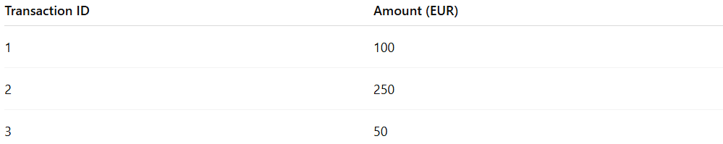
Transaction ID | Amount (EUR)
1 | 100
2 | 250
3 | 50
Assuming 1 EUR = 1.1 USD, after conversion:
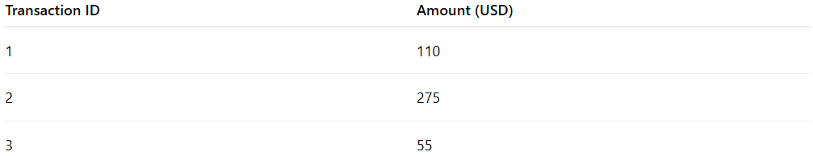
Transaction ID | Amount (USD)
1 | 110
2 | 275
3 | 55

Advantages
# Source: AI Source: Provided by: [Data Path: Persons Table -> ID Column: 1, Name_En Column: Motasem Essam] -> From: [Chatgpt (GPT‑5 Mini)] on [12/10/2025]
- Enables consistent analysis across multiple currencies
- Facilitates financial reporting, aggregations, and comparisons
- Essential for global datasets

Disadvantages
# Source: AI Source: Provided by: [Data Path: Persons Table -> ID Column: 1, Name_En Column: Motasem Essam] -> From: [Chatgpt (GPT‑5 Mini)] on [12/10/2025]
- Requires up-to-date and accurate exchange rates
- Historical data may require date-specific conversion rates
- Currency fluctuations may affect comparability over time

